FASB Codification (ASC)
ACC 320

On Blackboard in Course Content Information you will find the login information that you need to access the FASB’s Codification – the URL, the user ID, and the password. Additionally, you will find a Learning Guide that will help you use the Codification, as well as show you proper citation. Do NOT use the URL that is within the pdf file lesson on logging into the Codification in The Guide. Universities have a different login URL. Again, I have provided you with a direct link to the proper login URL on Blackboard.

The Accounting Standards Codification (ASC) is the single source of GAAP in the United States. Thus, you must learn how to navigate The Codification to research accounting questions. This assignment is designed to expose you to The Codification and begin the process of learning how to navigate around the ASC and research accounting principles to determine the appropriate reporting/recognizing treatment for an economic activity (business transaction).

Answer the following general questions.

- The Codification (ASC) content is organized by subject matter in a hierarchy. The highest level is the area. What are the remaining levels in the hierarchy?
The remaining levels in the hierarchy
- Topic – represents the broad categories with the code, they are represented by three digits’ topic codes.
- Subtopic – Narrower look at the topic
- Section – Uniform headings
- Subsection - organize paragraphs
- Paragraph group – provides guidance on standard
- Paragraph -
- Subparagraph.
- To research accounting principles efficiently you should know each of the areas in the ASC. You need to know the areas so that you can more easily find the Topic and Subtopic of your research question. Log in to the ASC and on the left-hand side the areas are listed. How many areas are there in the ASC? List each of the areas by including the title and the numbering that is specific to each area. For example, General Principles – 1xx. Include a screenshot showing where you obtained this information.
There are nine areas listed in ASC:
General Principles – 1xx
Presentation – 2xx
Assets – 3xx
Liabilities – 4xx
Equity – 5xx
Revenue – 6xx
Expenses – 7xx
Broad Transactions – 8xx
Industry – 9xx

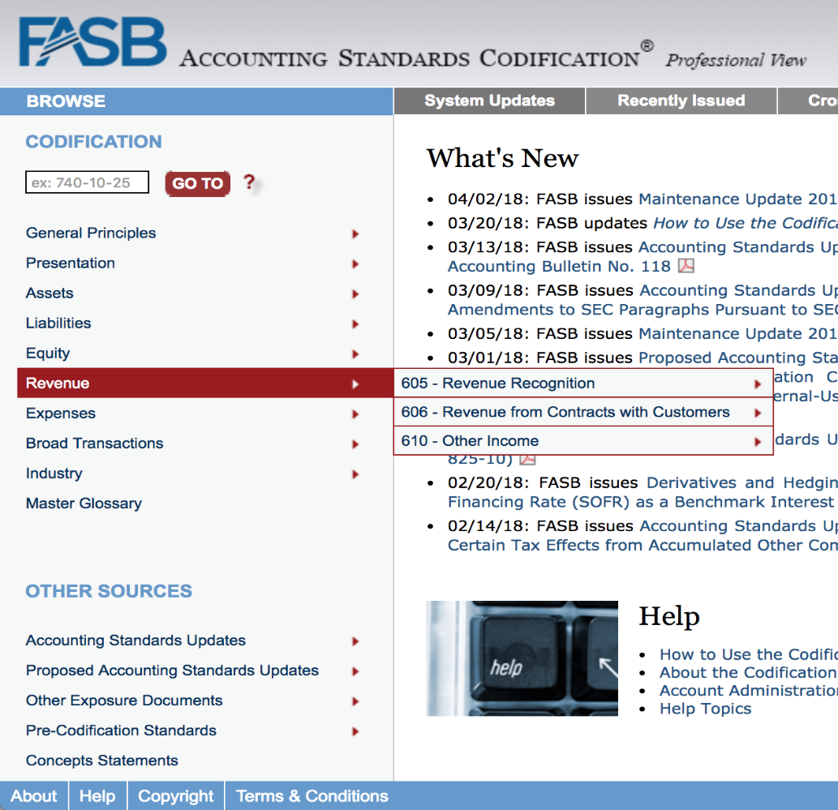
- The more familiar you are with the Codification’s specific Sections, the faster you will be at finding answers to your research questions. Fortunately, it is easy to familiarize yourself with the Codification’s Sections because they are standardized across all of the Codification’s Subtopics. What are the standardized sections? In your answer include the number and title of the standardized sections.
00 – Status
05 – Overview and Background
10 – Objectives
15 – Scope and Scope exceptions
20 – Glossary
25 – Recognition
30 – Initial Measurement
32 – Measurement
35 – Subsequent Measurement
40 – Derecognition
45 – Other Presentation Matters
50 – Disclosure
55 – Implementation Guidance and Illustrations
60 – Relationships
65 – Transition and Open Effective Date Information
70 – Grandfathered Guidance
75 – XBRL Elements

- Sections are the only pages with Codification content that answers your research question. Thus, you will need to navigate (drill down) to a specific Section or Sections to find answers to your research questions. Each Section in a Subtopic has its own “landing page”. Can you see the content of all of a Subtopic’s Sections on a single page? If so, how? Choose any Topic and Subtopic and provide a before and after screenshot of how the view changes in the Codification.
Yes, you can see the content of all subtopic’s section on a single page by using the “join all sections” feature.

- Proper citation of the ASC requires numerical referencing to the hierarchy to the specific location where you found the answer to your research question. Provide the citation of where you would begin your research for the following 4 areas and include the title after the citation. You don’t have to answer the question, only provide the citation for the question! For example, ASC 840-20-25-6: Leases – Operating leases – Recognition – Lease incentives.

- Determine what amount to record when you acquire a receivable when you sold service.
ASC 310-10-25-2: Receivables- Overall- Recognition- Recognition of Certain Types of Receivables
- Resolve a question related to the way an airline company recognizes revenue.
ASC 908-605-25-6: Airlines- Revenue Recognition- Recognition- Sampling Method
- Determine whether to recognize a contingent loss liability.
ASC 450-20-25-1: Contingencies- Loss Contingencies- Recognition- General Rule
- Where you would find a listing of the items that should appear in other comprehensive income (OCI)?
ASC 220-10-45-10A: Income Statement Reporting Comprehensive Income- Overall- Other Presentation Matters- Items within Other Comprehensive Income

